Control

Bus

Data

Bus

Address

Bus

Console

Printer

keyboard

Mouse

HDD,

SDD,

CD

RAM,

ROM

secondary

primary

Math

Co-processor

Motherboard

GPU

Storage

Devices

Input

Devices

Output

Devices

System Bus

Microprocessor

components of Computer

Microprocessor

(CPU)

Executable

(Binary Language)

ToolChain

Using Programming

Languages

write the program

Programmer

Any Programming Language

VM:

Virtual Machine based Programming

OOP:

Object Oriented Programming

POP:

Procedure Oriented Programmingg

C

Python

JAVA

C++

Provided by OS

Programmer

Hardware

Process in RAM (Primary storage)

Microprocessor

Demo.asm /Demo.s

Demo.exe

Demo.obj

Demo.i

Demo.c

Preprocessor

Editor

Compiler

Assembler

Linker

Loader

**input output**

Preprocessor

**Demo.i (intermediate)**

Human understandable/Readable

**Demo.c**

Human understandable/Readable

**inin**

Demo. exe (HDD)

Loader

Process (Primary Storage)RAM

**Demo.exe**

**Binary File(executable)**

Linker

**Demo.Obj**

**Binary File(non Executable)**

**Demo.Obj**

**Binary File(non Executable)**

Assembler

**Demo.asm /.s(Machine Dependent)**

Human understandable/Readable

**Demo.asm /.s(Machine Dependent)**

Human understandable/Readable

Compiler

**Demo.i**

Human understandable/Readable

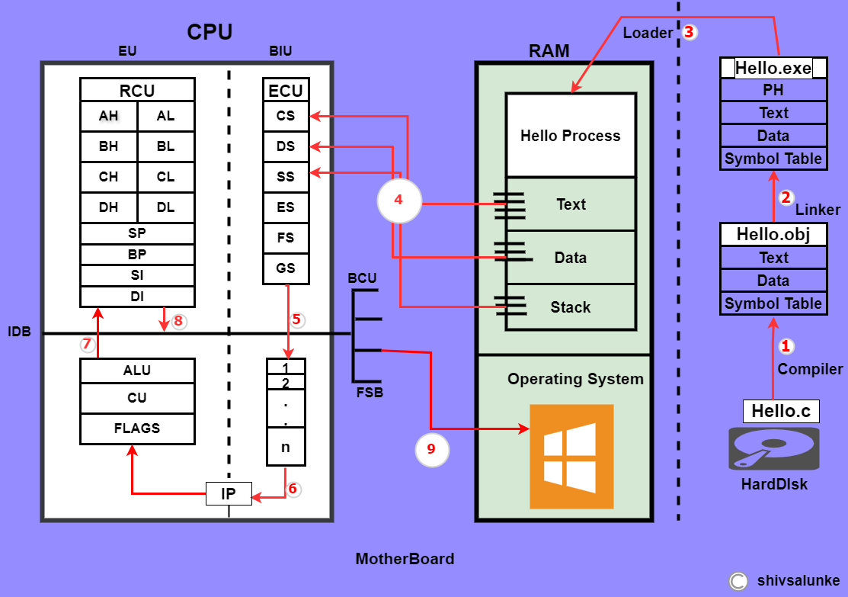

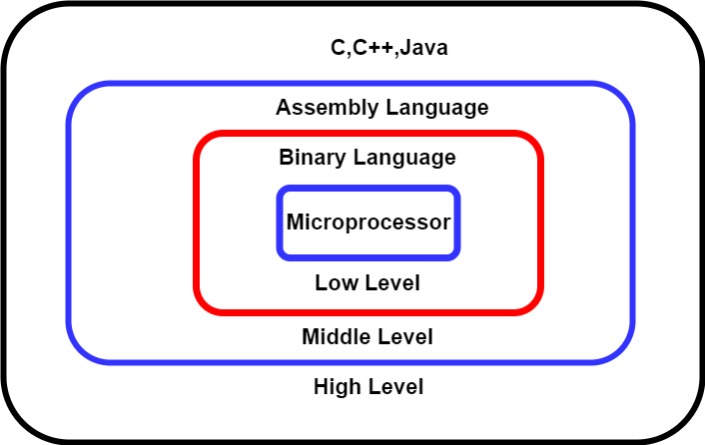

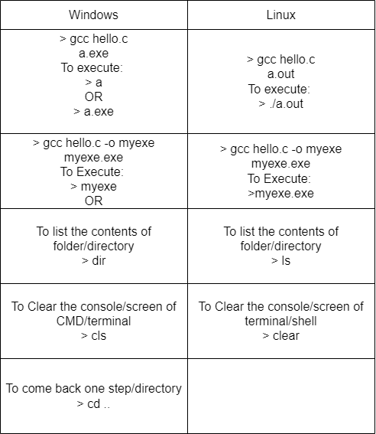

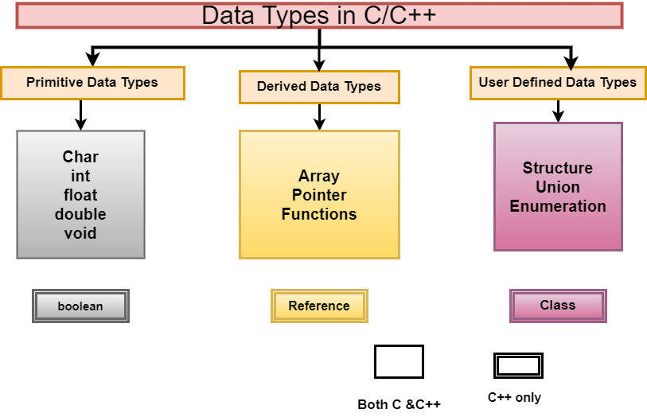

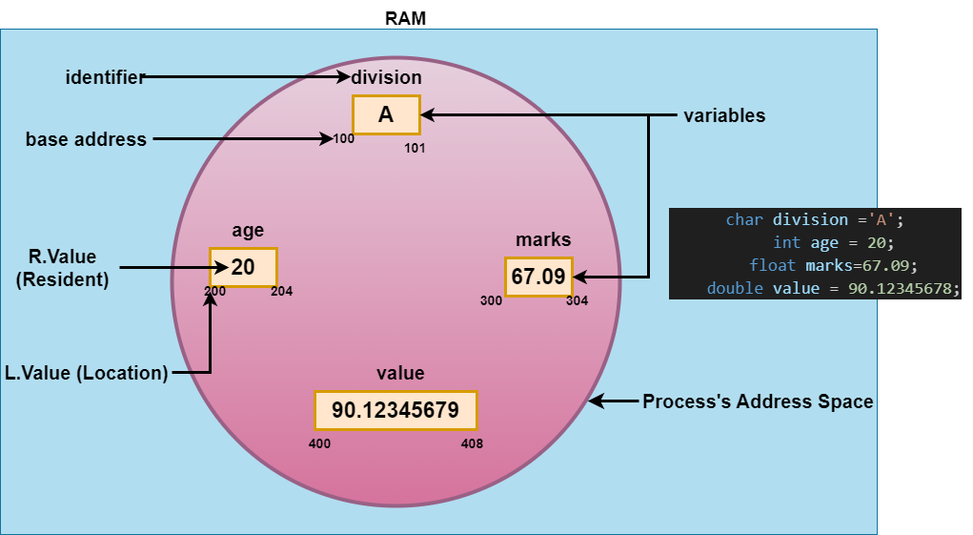

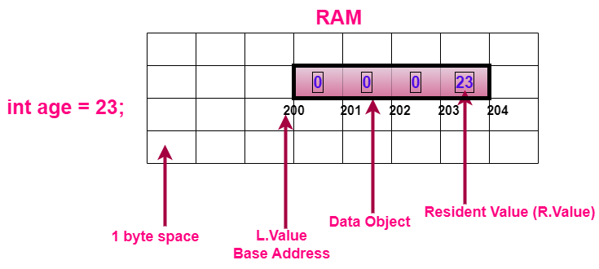

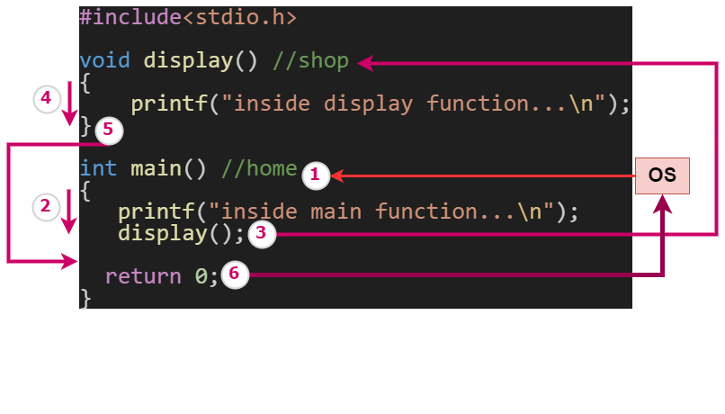

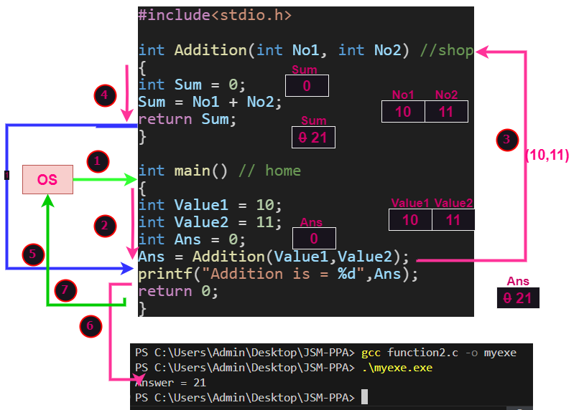

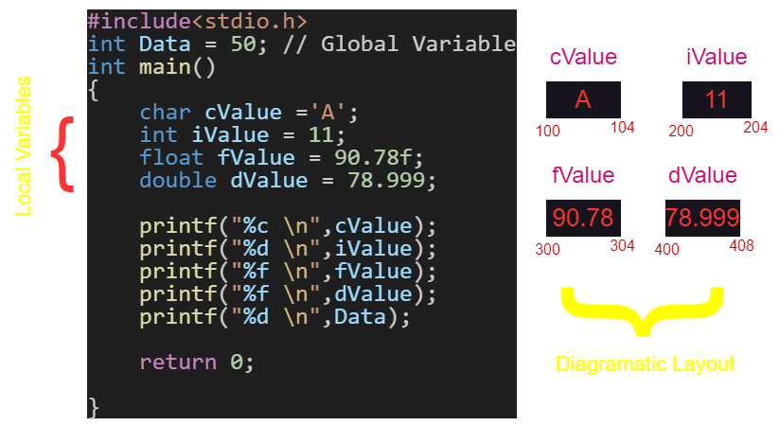

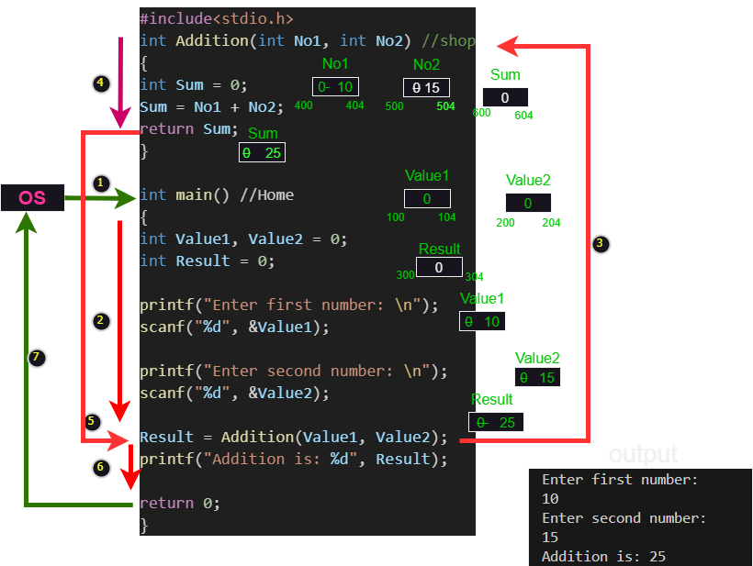

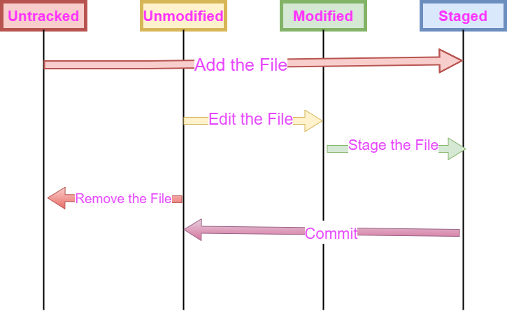

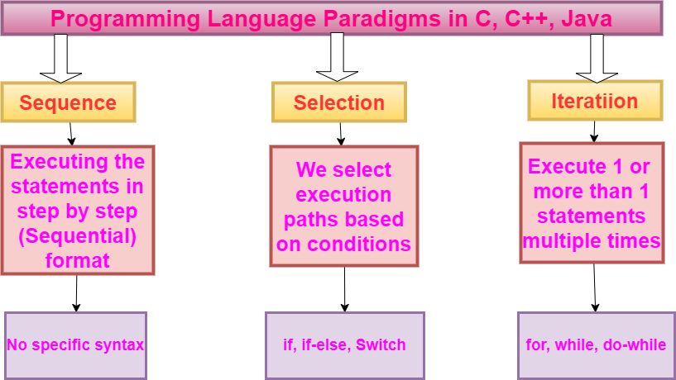

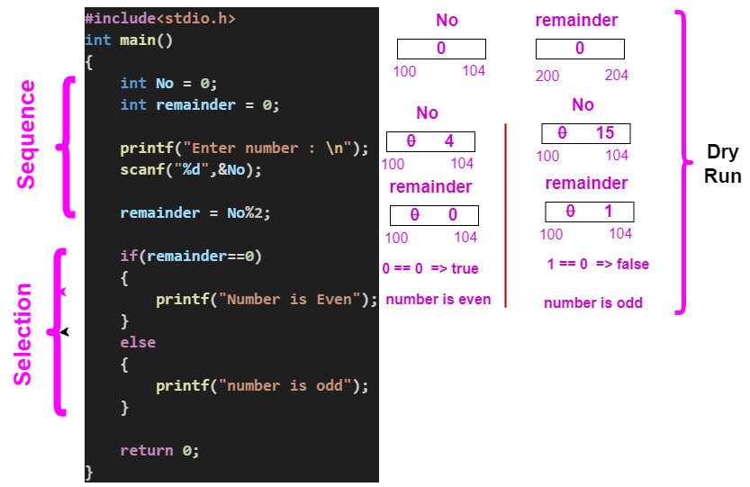

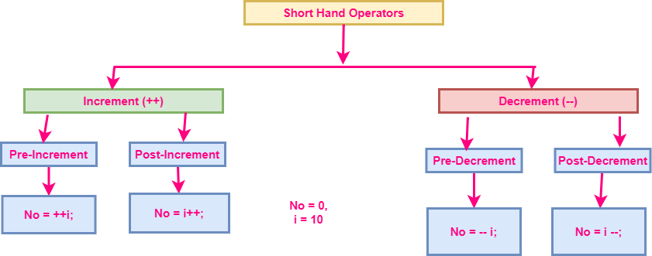

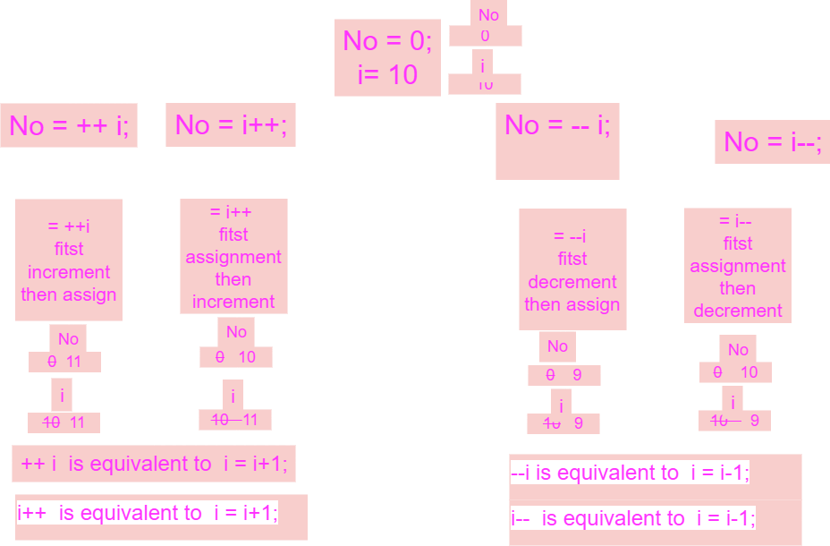

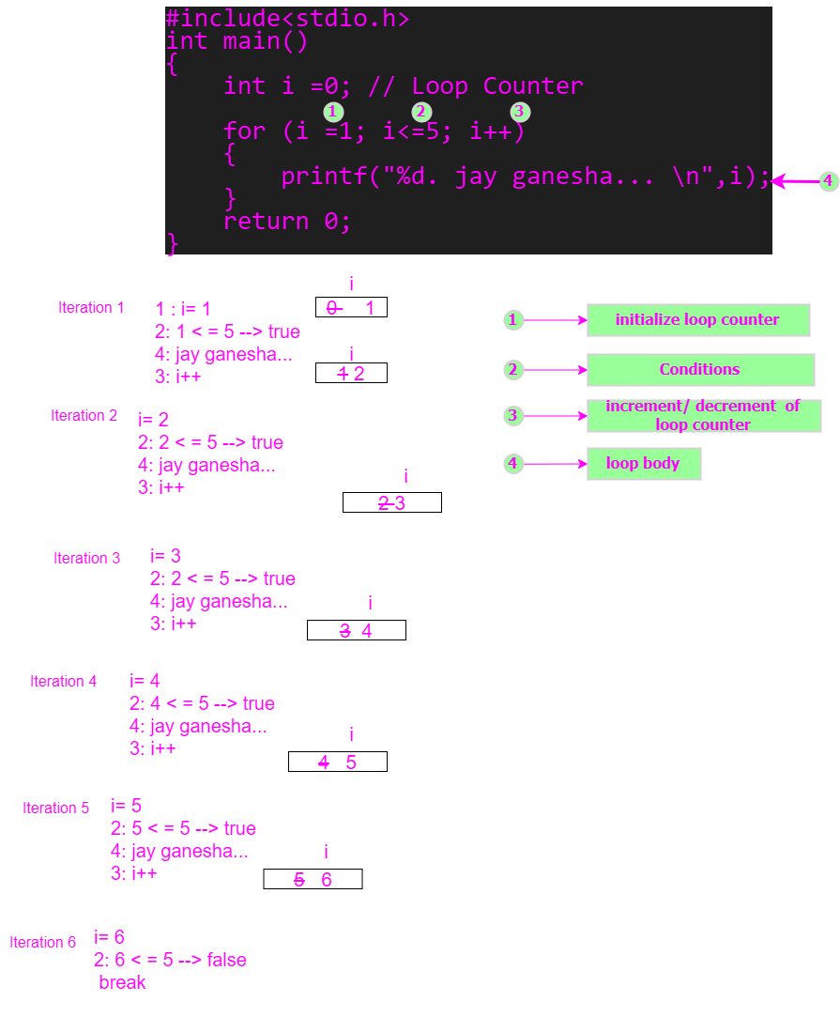

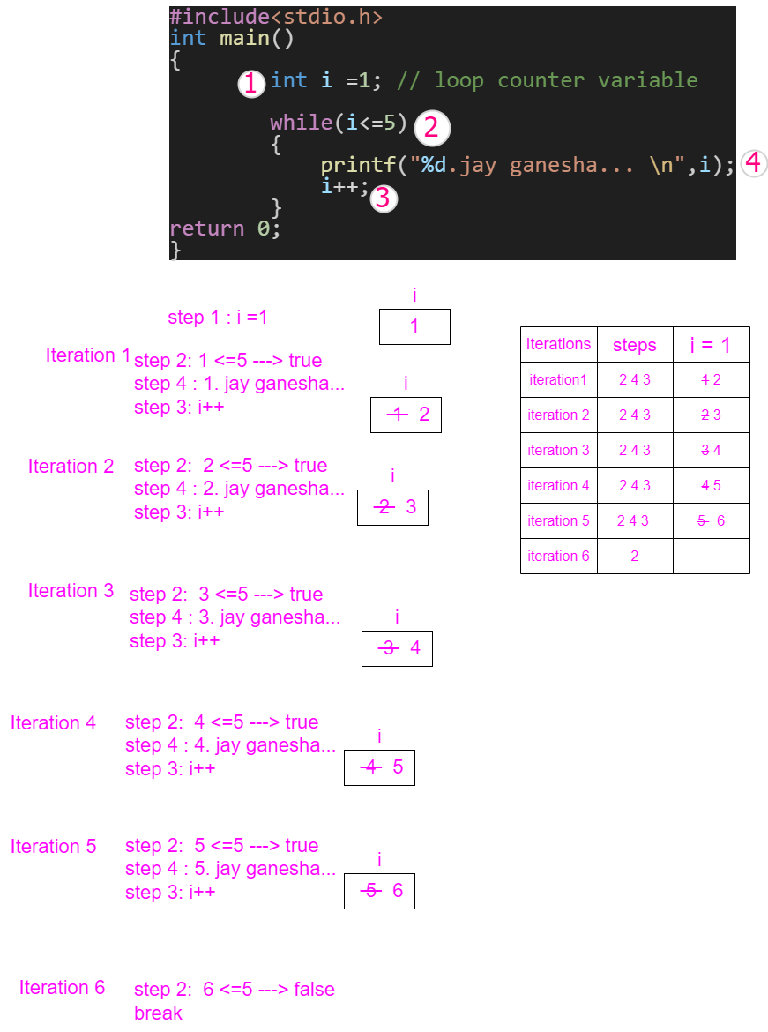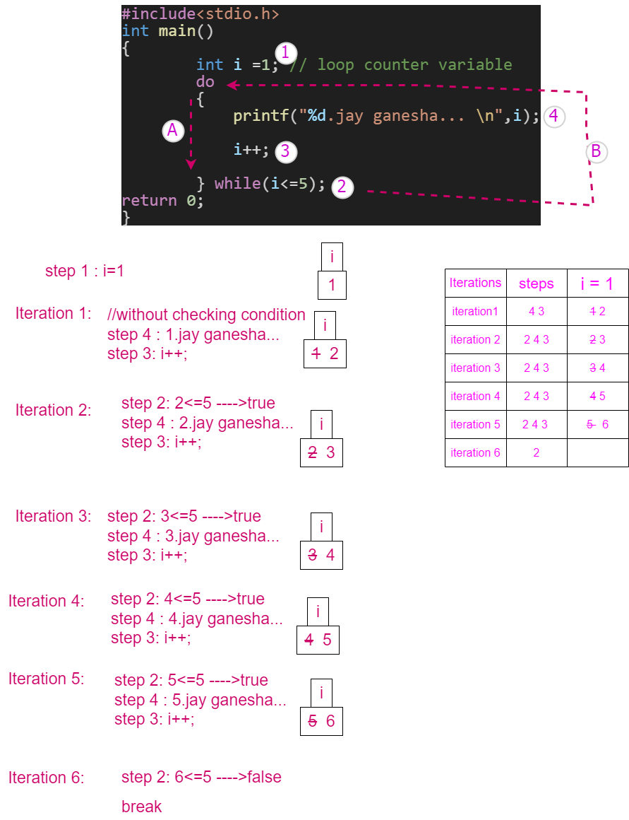

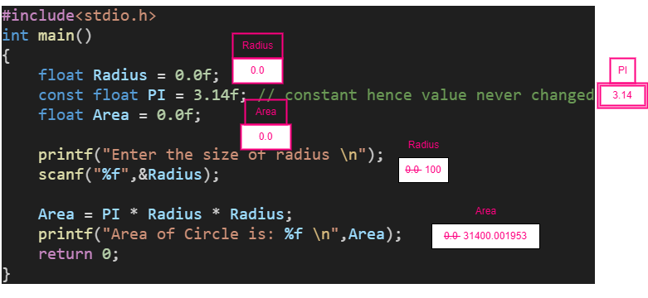

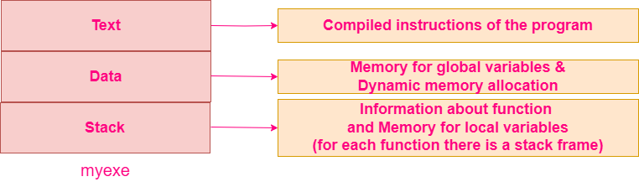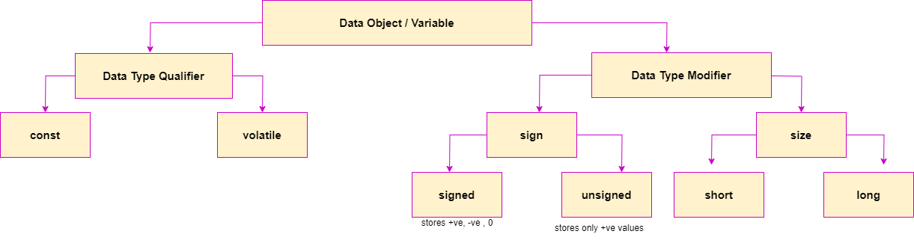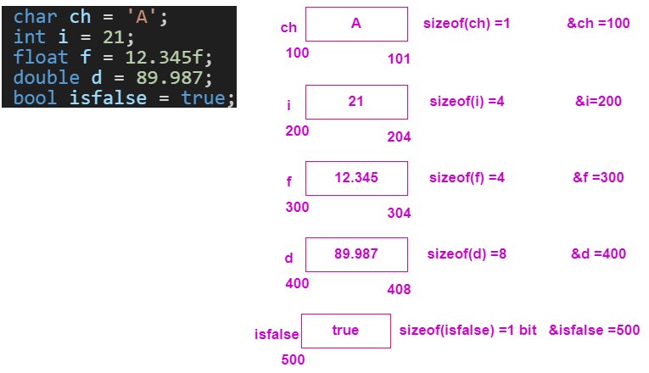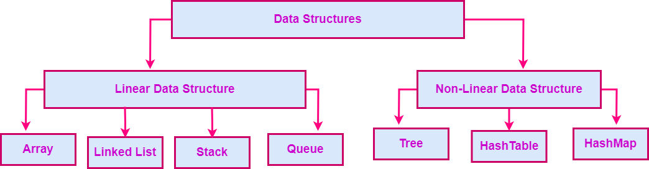

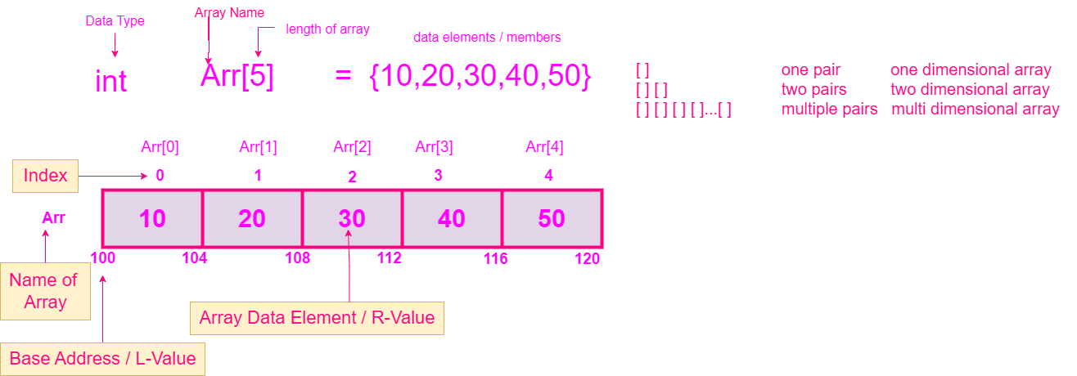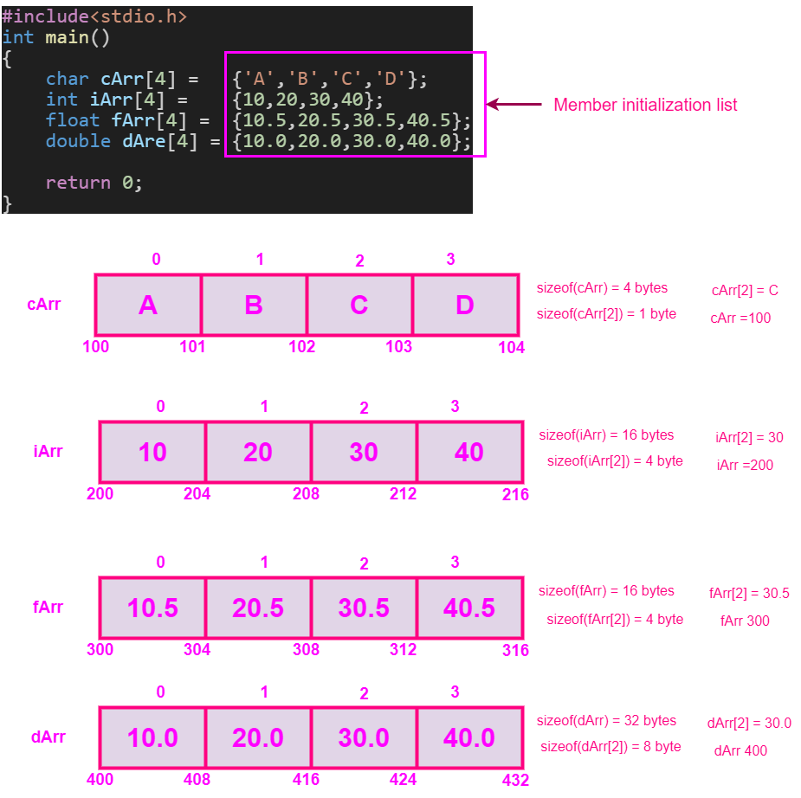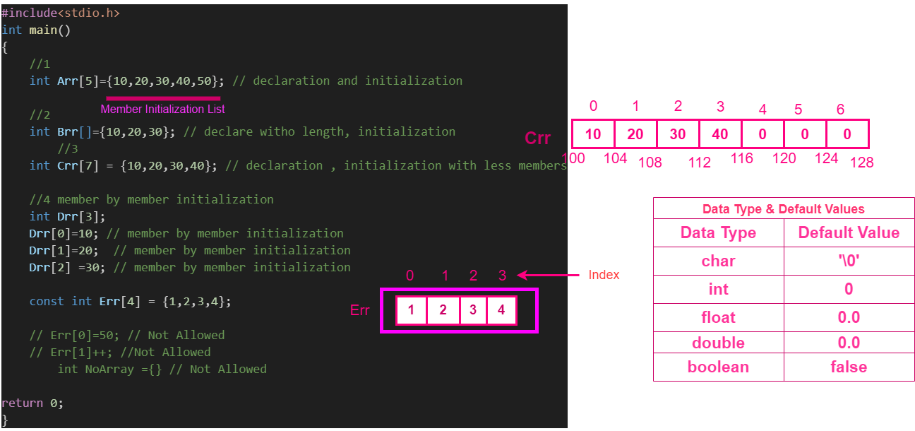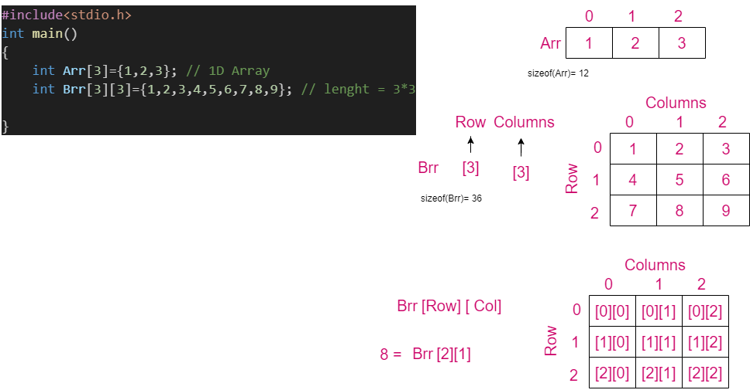

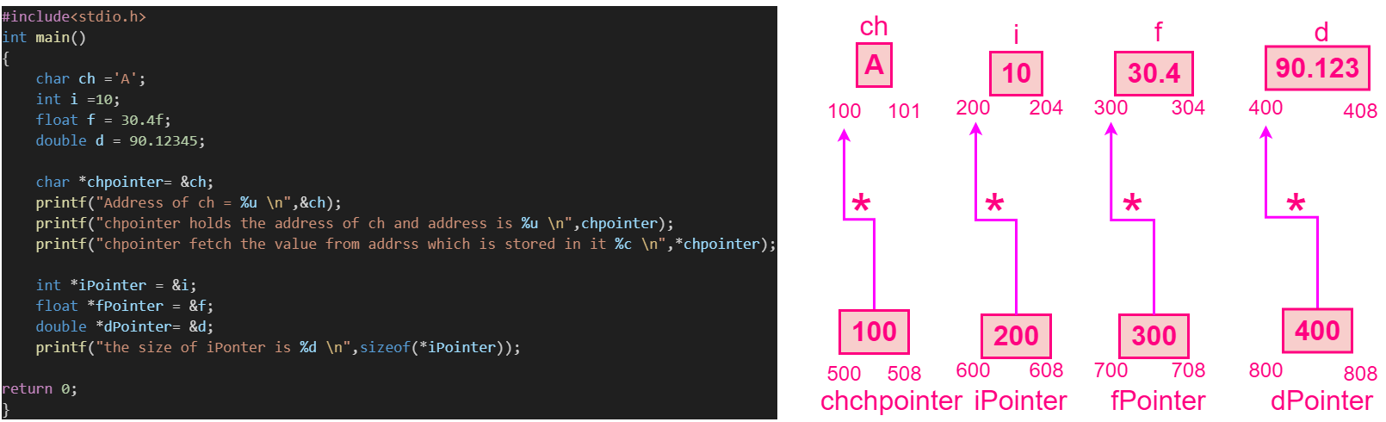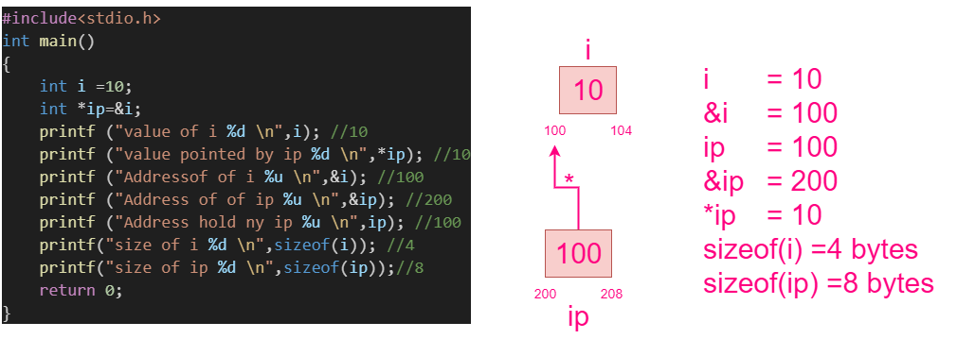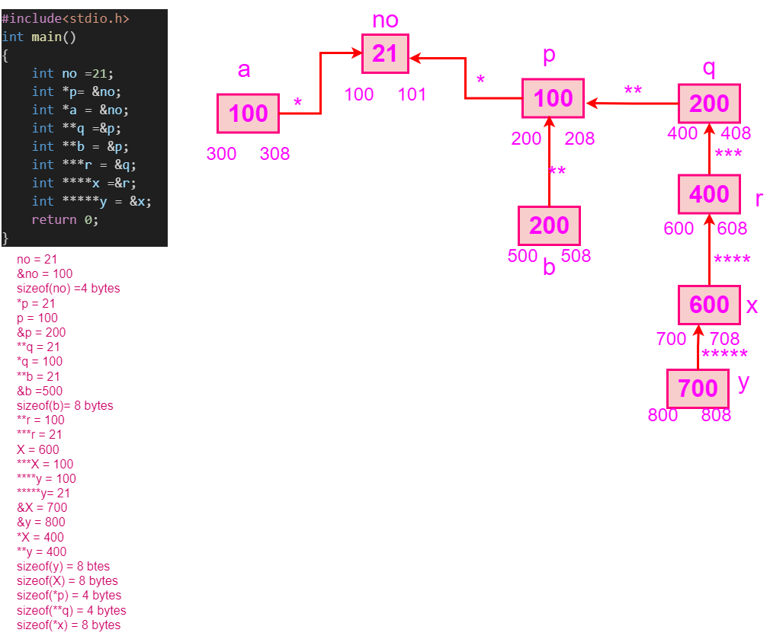

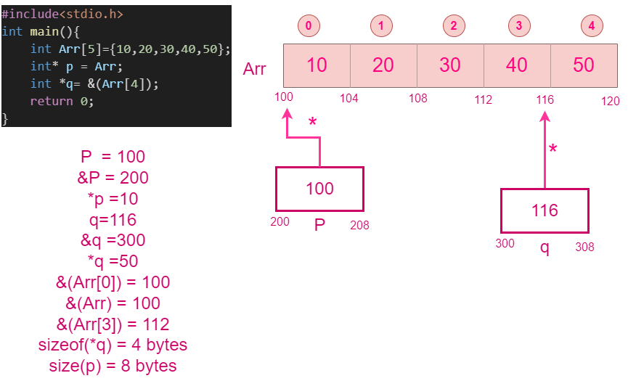

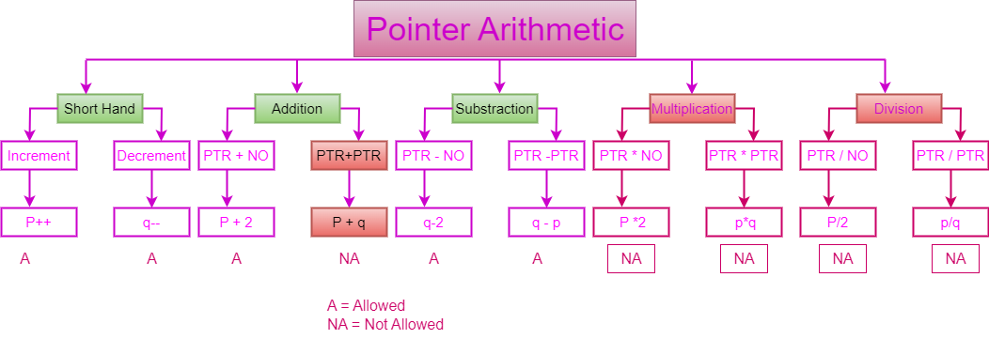

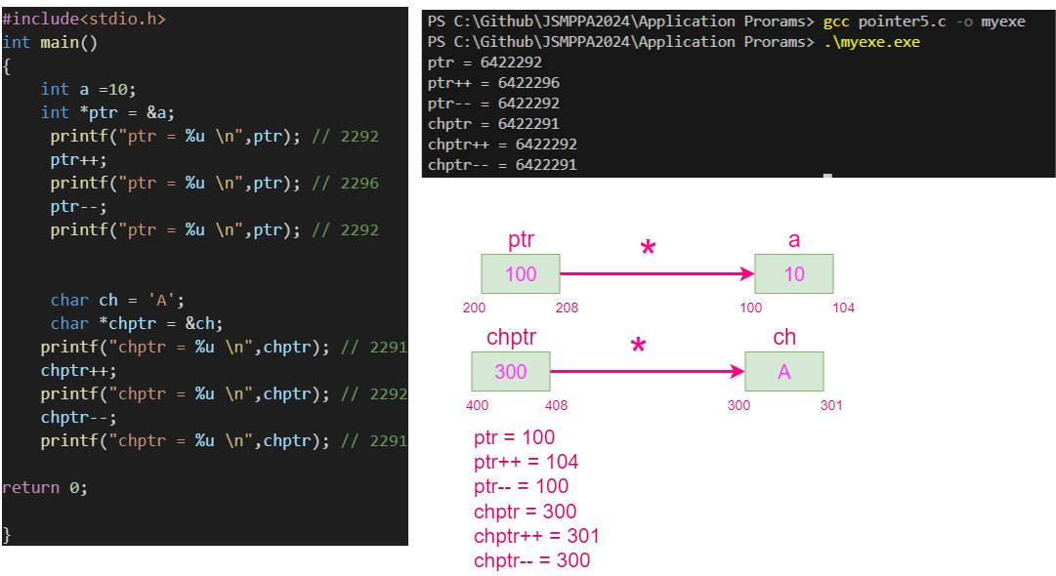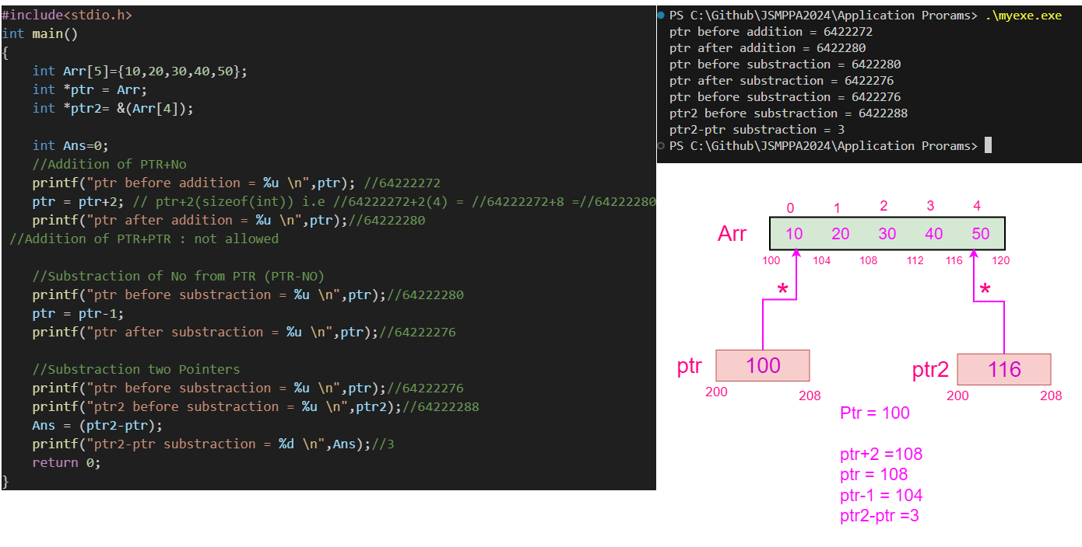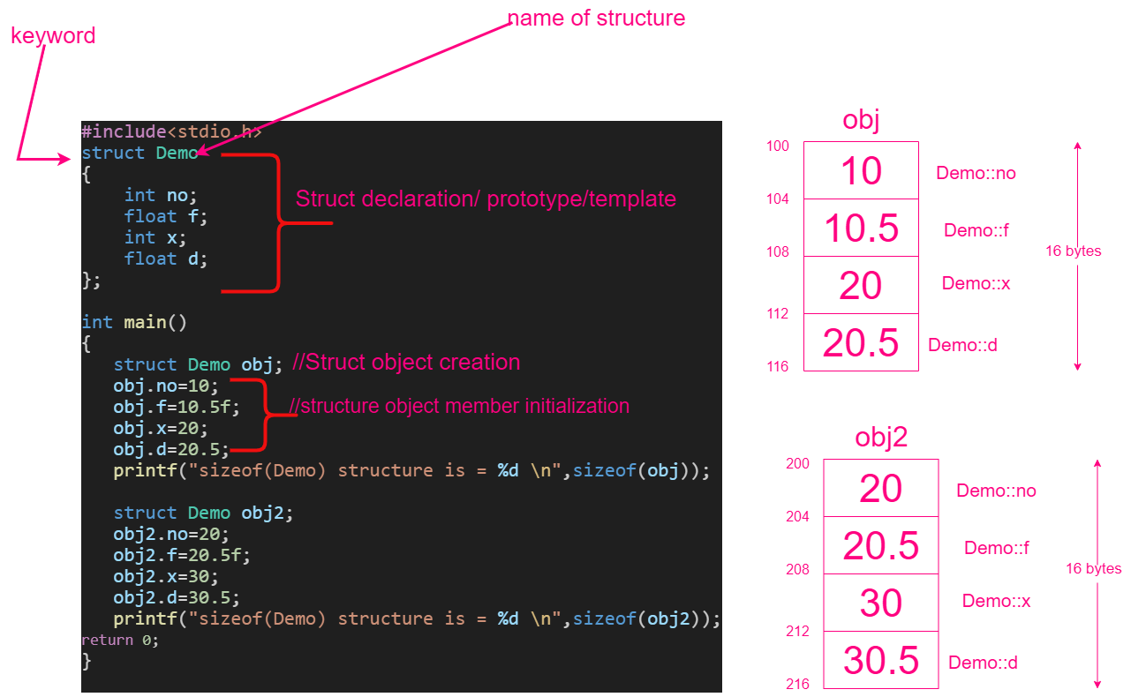

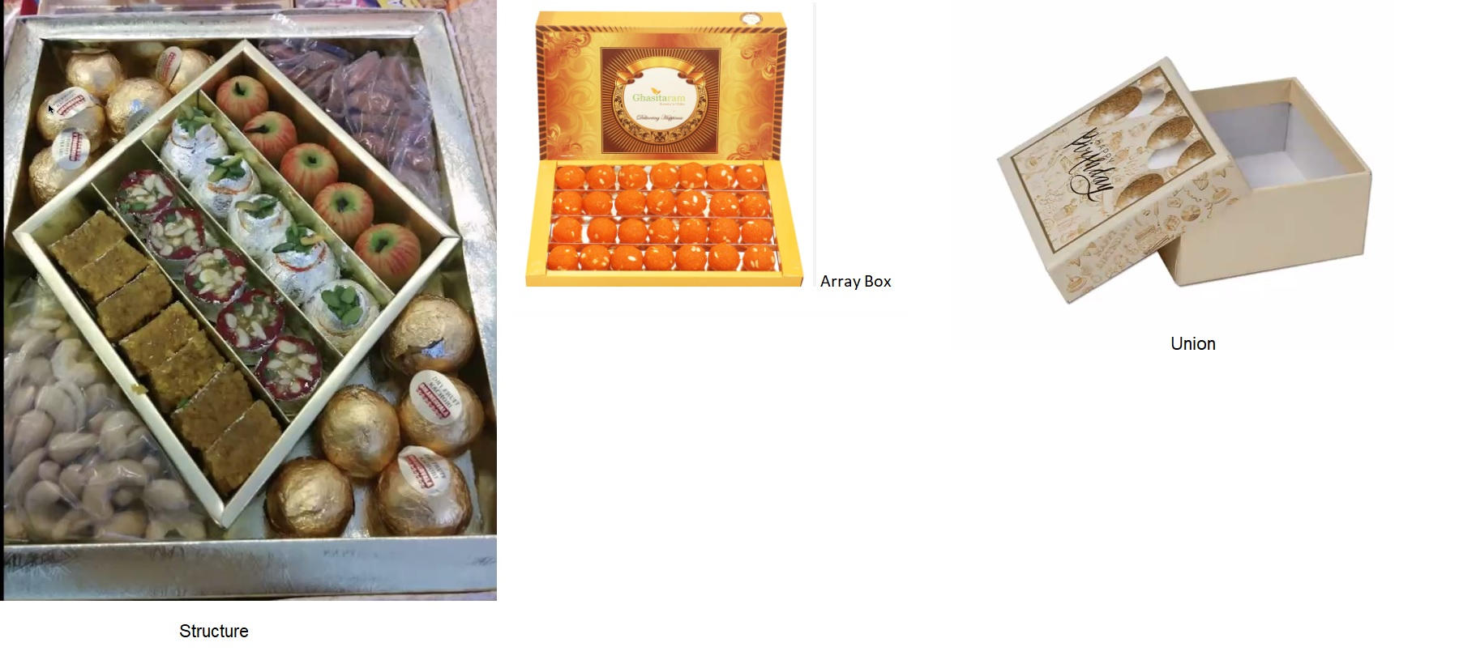

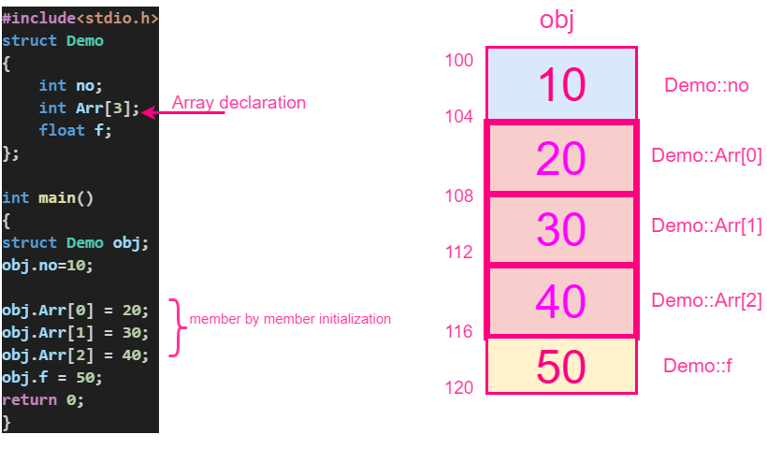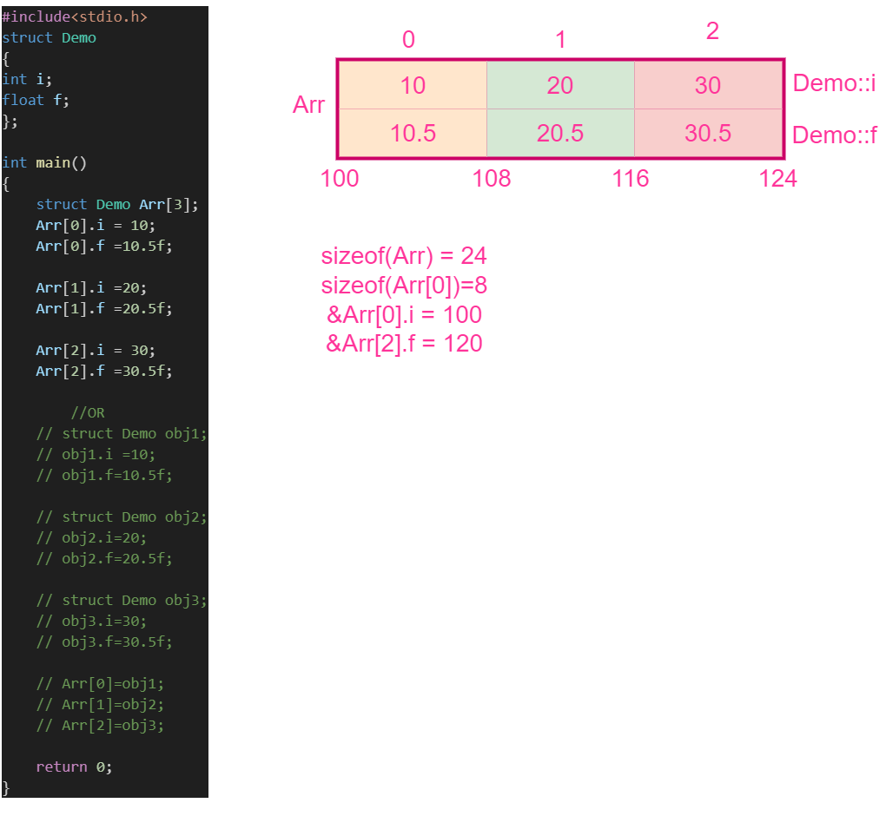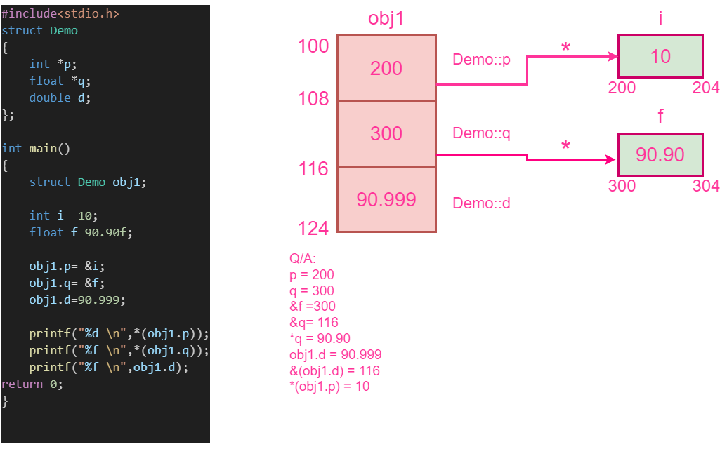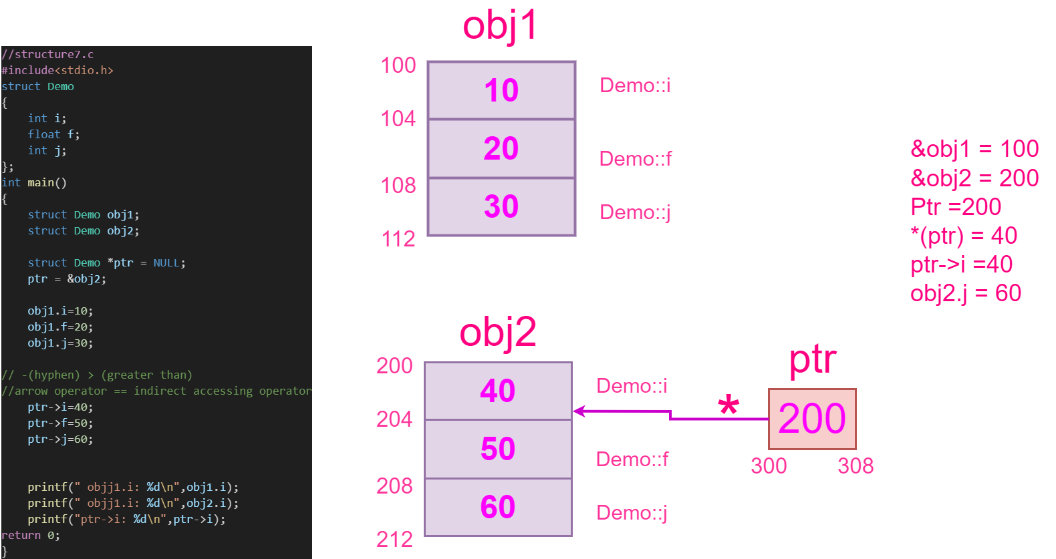

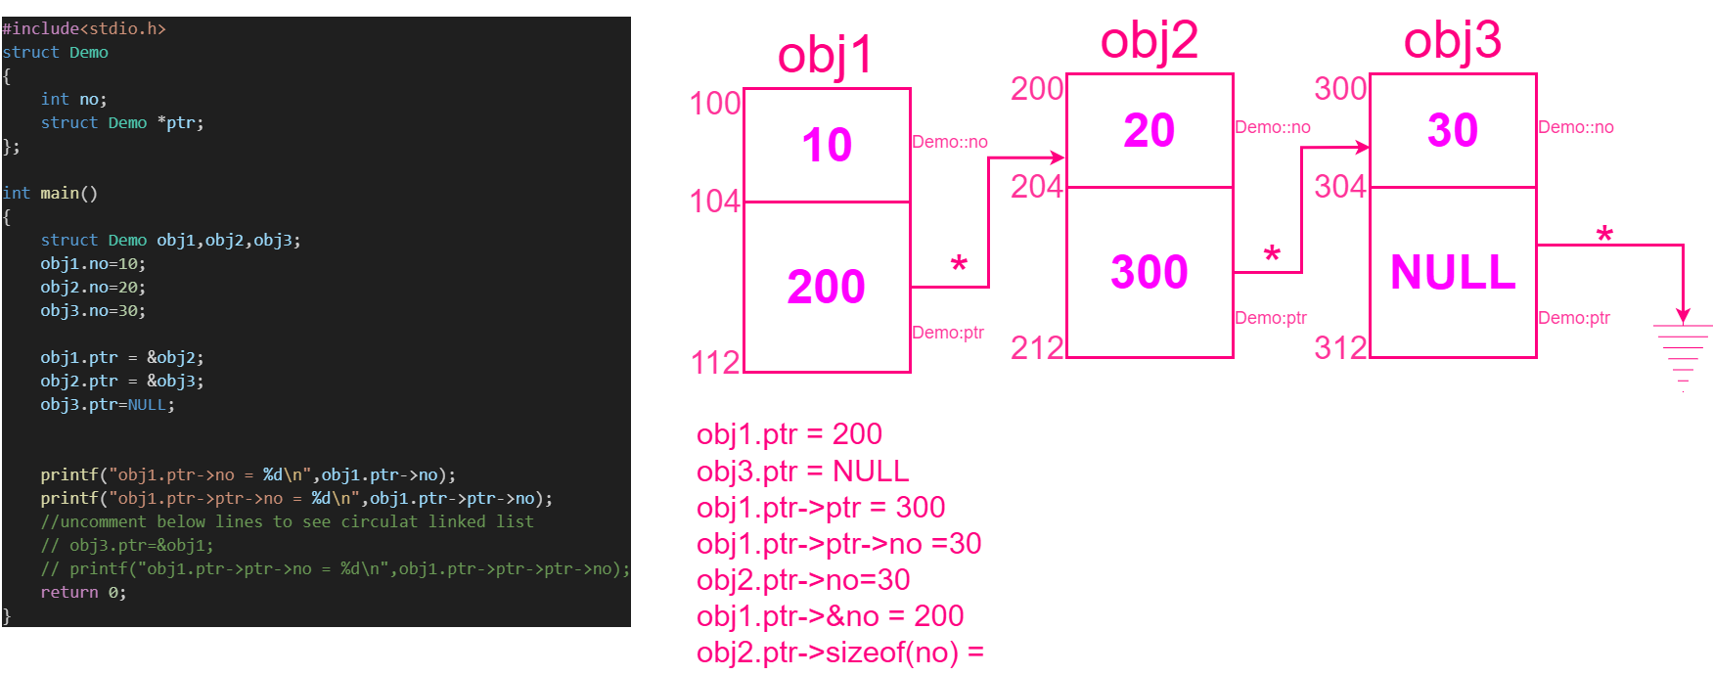

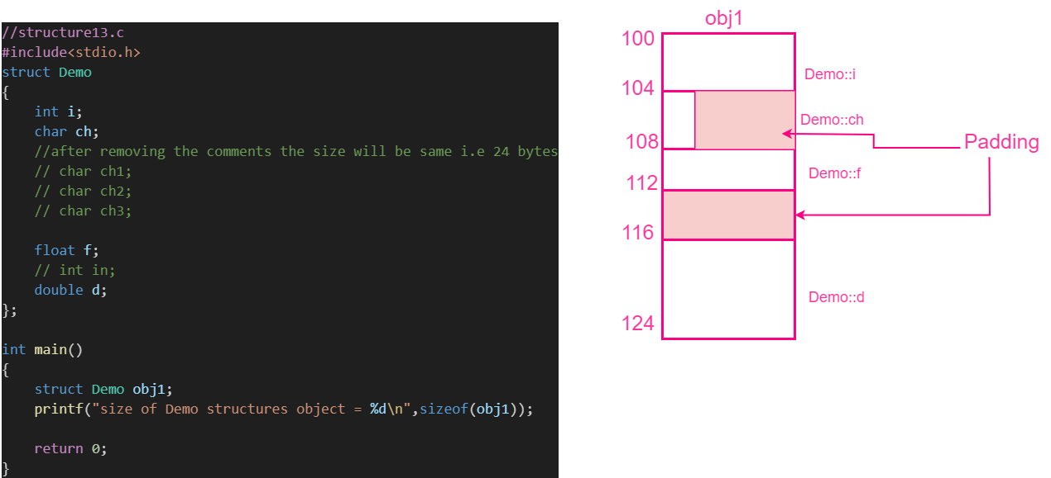

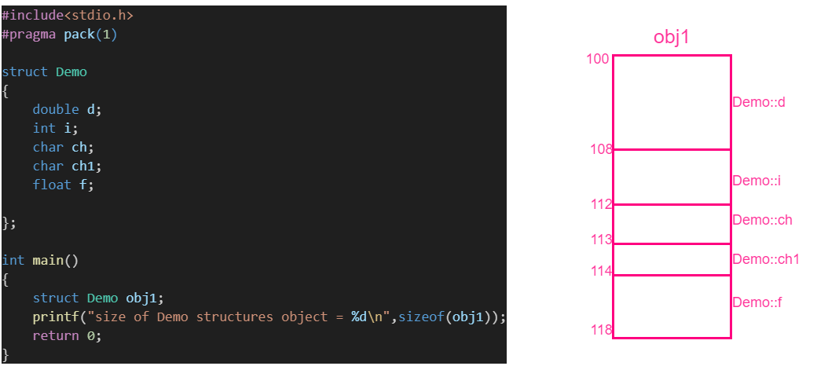

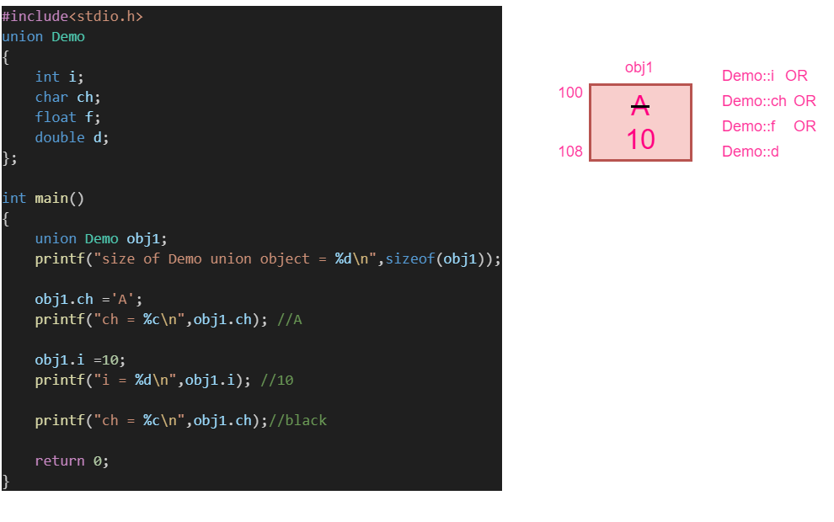

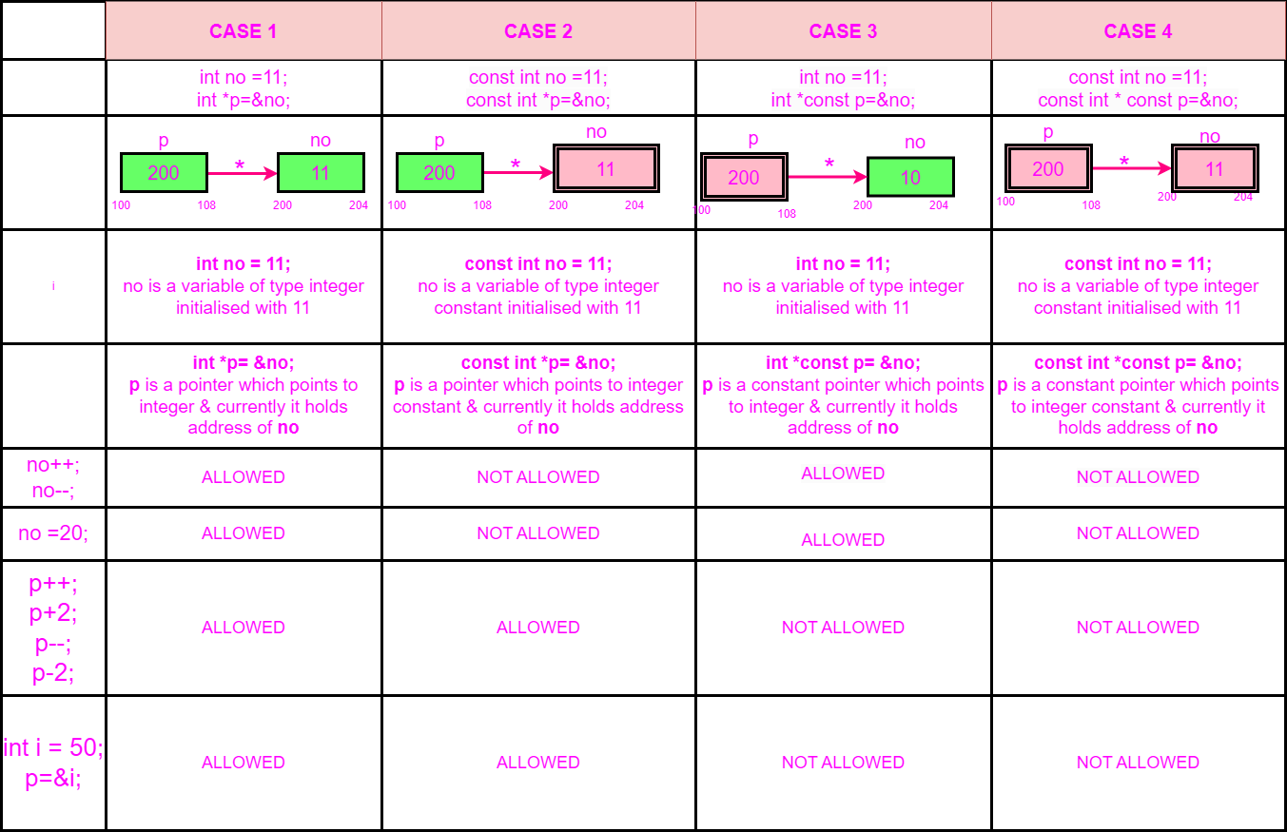

**PPA batch Time-Table**

